**<http://global.tommy.com/india/en/sitecore/content/websites/archives/india/removed-collections/collections/tommyxgigi/20>**

India is the second largest producer of fibre in the world and the major fibre produced is [cotton](https://en.wikipedia.org/wiki/Cotton)

# UNIQUE AND PERSONALISED

To create something truly unique, John Hagger and the Tanner Bates design team are well versed in crafting tailor-made leather products that fully embody your company’s corporate ID or follow a design brief for a special bespoke project.

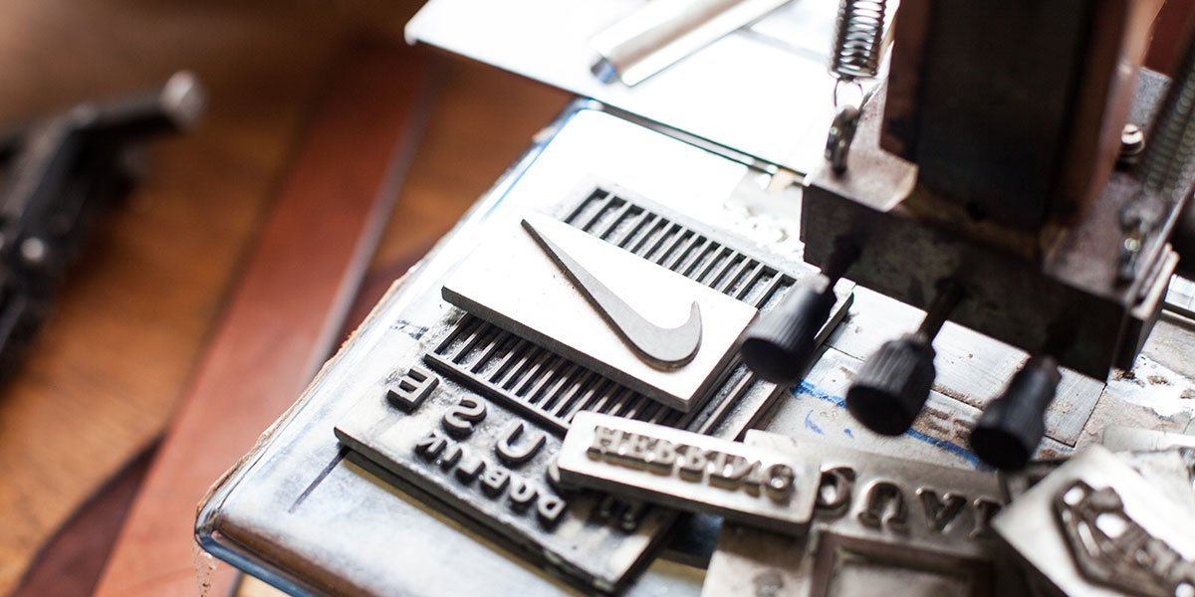

­­

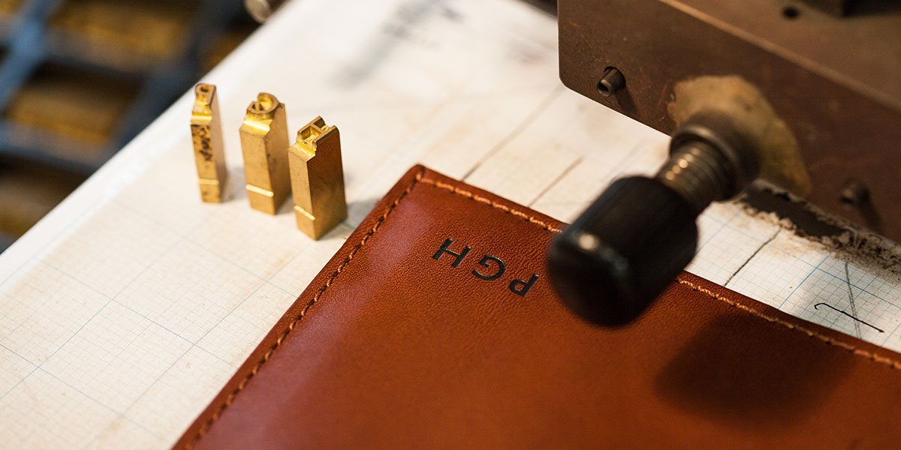

#### [CONTACT US](https://www.tannerbates.co.uk/pages/contact-us) NOW AND WE WILL HELP YOU CREATE THE PERFECT GIFT THAT WILL REFLECT THE SENTIMENT WITH WHICH IT IS GIVEN.

### Privacy Policy

This privacy policy sets out how Harriet Sanders Limited (also referred to as “we”, “We”, “us” or “Us” throughout this page) uses and protects any information that you give us when you use this website (<http://www.harrietsanders.co.uk/>) and complies with UK GDPR regulations. We are committed to ensuring that your privacy is protected. Should we ask you to provide certain information by which you can be identified when using this website, then you can be assured that it will only be used in accordance with this privacy statement. We may change this policy from time to time by updating this page. You should check this page from time to time to ensure that you are happy with any changes. This policy is effective from 24th May 2018.

## What we collect

We may collect the following information:

* name and job title
* contact information including email address
* demographic information such as postcode, preferences and interests
* other information relevant to customer surveys and/or offers

## What we do with the information we gather

We require this information to understand your needs and provide you with a better service, and in particular for the following reasons:

* Internal record keeping
* We may use the information to improve our products and services
* We may periodically send promotional emails about new products, special offers, events or other information which we think you may find interesting using the email address which you have provided
* If you ask us for a quote by filling out a quote form or requesting information over the phone or via a messaging service eg WhatsApp or Facebook Messenger, we may also use your information to contact you by messaging service, email, phone, or mail
* If you sign up for our newsletter or promotional emails we will contact you from time to time with news we consider relevant and details of our services.

## Security

We are committed to ensuring that your information is secure. In order to prevent unauthorised access or disclosure, we have put in place suitable physical, electronic and managerial procedures to safeguard and secure the information we collect online.

## How we use cookies

A cookie is a small file which asks permission to be placed on your computer’s hard drive. Once you agree, the file is added and the cookie helps analyse web traffic or lets you know when you visit a particular site.

Cookies allow web applications to respond to you as an individual. The web application can tailor its operations to your needs, likes and dislikes by gathering and remembering information about your preferences.

We use traffic log cookies to identify which pages are being used. This helps us analyse data about web page traffic and improve our website in order to tailor it to customer needs. We only use this information for statistical analysis purposes and then the data is removed from the system.

Overall, cookies help us provide you with a better website, by enabling us to monitor which pages you find useful and which you do not. A cookie in no way gives us access to your computer or any information about you, other than the data you choose to share with us.

You can choose to accept or decline cookies. Most web browsers automatically accept cookies, but you can usually modify your browser setting to decline cookies if you prefer. This may prevent you from taking full advantage of the website.

## Facebook Pixel

The Facebook Pixel is a piece of code on our website which we may use to provide you with adverts on Facebook and Instagram.

## Links to other websites

Our website may contain links to other websites of interest. However, once you have used these links to leave our site, you should note that we do not have any control over that other website. Therefore, we cannot be responsible for the protection and privacy of any information which you provide whilst visiting such sites and such sites are not governed by this privacy statement. You should exercise caution and look at the privacy statement applicable to the website in question.

## Controlling your personal information – GDPR

We will not sell, distribute or lease your personal information to third parties unless we have your permission or are required by law to do so. We may use your personal information to send you promotional information about third parties which we think you may find interesting.

## Clients

We may hold the following information on our clients:

* Name
* Business Address
* Telephone Number
* Email
* Website Address

The information is stored in:

* Our email system
* Mailchimp (if you have double opted in to our newsletter)
* Paper files, for order fulfilment

We do not hold any bank detail or payment card information. If bank detail or payment information is provided by a client it will be deleted within 24 hours.

## Prospects

We may hold the following personal information on our prospects:

* Name
* Business Address
* Telephone Number
* Email
* Website Address
* Site login details

To request to have your information removed from our files please contact us on our [contact page](http://www.harrietsanders.co.uk/contact/) with your request, stating name and email address.

### Terms and conditions

Please read through them carefully before placing your order. By using this website and/or placing an order you agree to be bound by the terms and conditions set out below. Please also read our privacy notice regarding personal information provided by you. Before placing an order, if you have any queries relating to these terms and conditions, please email Harriet on [info@harrietsanders.co.uk](mailto:info@harrietsanders.co.uk) We may change these terms from time to time without notice to you. Changes will apply to any subsequent orders received. Once your order has been confirmed, we will not be able to make any changes.

## Privacy notice

All personal details given by customers on this site are STRICTLY CONFIDENTIAL and not shared with or made available to any other parties. Please be assured your privacy is 100% protected.  GDPR (General Data Protection Regulations) are in force with all data we hold.  We request only data relevant to your order.  Your data is used solely for the purpose of your order.  Your data is held securely and used fairly.  We only hold your data for as long as needed.

You can find out more about this on our [Privacy Policy](http://www.harrietsanders.co.uk/privacy-policy/) page.

## UK delivery options

Bags are made to order and take up to 21 working days to complete. We aim to get your order to you as soon as possible. However, due to unforeseen circumstances (such as illness, weather or other such causes affecting deliveries, extremely busy order periods such as Christmas) there may be a delay to your order and it may take longer than the suggested time period.  Please appreciate that each handbag is made to order by Harriet and not mass produced, you have ordered a unique item. Orders are posted between Monday and Friday. All orders are sent 1st Class Recorded Delivery. Postage costs are £6 within the UK and £12 for orders outside the UK. We will send you a confirmation email to say your order has been posted. Please allow up to 5 working days for UK orders to arrive and up to 10 days for Overseas orders to arrive. If after this time you still have not received your order please contact us via email at [info@harrietsanders.co.uk](mailto:info@harrietsanders.co.uk) and we will track your order.  Please ensure all delivery details are correct at time of order and again on your confirmation email.  It is the customer’s responsibility to provide us with a correct address.  Providing an address that is incomplete, incorrect, or false for whatever reason will result in your delivery being delayed, lost, or returned.  Harriet Sanders Ltd is not responsible for any parcels lost due to the customer providing an incorrect address.  If you notice a problem with your address on your order, please contact us straight away.  Contacting us after dispatch is not acceptable.  Returned parcels will require postage to be paid for again.  Lost parcels are the customer’s responsibility.  Please note: all deliveries require a signature.  It is your responsibility to sign for your delivery.  Harriet Sanders Ltd cannot be held responsible for orders signed for by anyone other than the person listed on the order/delivery.

## Payment methods

Worldpay or Paypal  
Card payment over the phone – Please call 01242 230154  
Cheque and postal orders — From UK Banks only please. Please make cheques payable to Harriet Sanders Ltd. Send to Harriet Sanders Ltd. Finance Department. 31 Space Business Centre, Tewkesbury Road, Cheltenham, Gloucestershire, GL51 9FL.  Orders will not go into production until payment has cleared. Orders must still be placed through the website, select the ‘pay by cheque’ option at the checkout.

## Returns

We will happily exchange any faulty or unsuitable items within seven days of you receiving the item. Please ask about extensions to exchange time during Christmas Period. Postage and Packaging is non-refundable. Bags must be returned in original and re-saleable condition. Contact us via email or phone to discuss the returning of your item. We do not offer refunds on any of our products due to each bag being individually handmade to order.  Exchanges and Credit Notes authorised at Harriet Sanders Ltd discretion. Please note: All bags are genuine leather and lined with suede. Leather is a natural material and will age and soften as the bag is used. This is not an acceptable reason for returning a bag or accessory within any time period.

## Bespoke

All Bespoke orders require full payment upfront. You will be given a full detailed description and/or a design drawing. Once agreement has been made on all aspects of the Bespoke design and full payment has been made, the bag will be put into production. Bespoke orders are non-refundable and non-returnable. Adjustments to the design are not accepted during or after production. Any adjustments requested after order but before production may incur a surcharge. Every effort is made to illustrate and explain the design proposal. By making payment for a Bespoke design you are entering into a binding contract where by you accept the final product.

## Product information

We have made every effort to display as accurately as possible the colours of our products that appear on the website. However, the actual colours you see will depend on your monitor. We cannot guarantee that your monitor’s display of any colour will accurately reflect the colour of thc product on delivery.

Names for colours can be subjective and cannot be used as accurate definitions for the colour of bag you may receive.  Where possible we aim to be as accurate as we can.  If in doubt, please contact us for swatches to be sent to you.

All sizes and measurcmcnts are approximate, however we do make every effort to ensure they are as accurate as possible. Unless otherwise stated, sizes indicated are UK sizes.

Our handbags are based on simple design structures that include ‘cut edge’ and ‘turn seam’.  ‘Cut edge’ bags will display the raw edge of the leather and on occasion the suede lining will be visible on the outside of the bag.  This is part of the design.  All bags are hand cut.  The interior of the bags is suede, and will not appear like a standard ‘drop in’ fabric lining.  Internal seams may be visible.

We will take all reasonable care to ensure that all details, descriptions and prices of products appearing on the website are correct at the time when the relevant information was entered onto the system. We reserve the right to refuse orders where product information has been mis-published, including prices and promotions. Prices are subject to change without notice.

Goods are subject to availability & there is a delay between the time when the order is placed and the time when the order is accepted, the stock position relating to particular items may change. If an item you have ordered becomes out of stock before we accept the order, we shall notify you as soon as possible.

## Purchase of products

When you place an order on our website we shall email you an acknowledgement (this may go to your junk/spam folder). Our acceptance of an order does not take place until dispatch of the order. Once you have checked out and your order has been confirmed you will not be able to make any changes to your order so please make sure that everything is correct before clicking the confirm button.

By placing an order on our website, you enter into and agree to our terms and conditions. Please ensure all details are correct with your order before confirming.  Any queries, please contact us before placing your order.  Once the order is confirmed, you enter into a contract with Harriet Sanders Ltd, and agree to all terms and conditions stated.  Any queries or amendments to these terms and conditions are solely at Harriet Sanders Ltd’s discretion.

We reserve the right to refuse an order. Non-acceptance of an order may, for example, result from one of the following:  
The product ordered being unavailable from stock  
Our inability to obtain authorisation of payment.  
The identification of an error within the product information, including price or promotion.

If there are any problems with your order we shall contact you. We reserve the right to reject any offer to purchase by you at any time. We will take all reasonable care, in so far as it is within our power to do so, to keep the details of your order and payment secure, but in the absence of negligence on our part we cannot be held liable for any loss you may suffer If a third party procures unauthorised access to any data you provide when accessing or ordering from the website.

## Company information

Registered Address:

31, Space Business Centre

Tewkesbury Road

Cheltenham

GL51 9FL

Company number: 07078090

01242 230154

**Values •** We are perfectionists, testing and crafting our products to the ultimate detail. We like simplicity and believe that a minimalistic and monochromatic design highlights the high-quality materials we source and the craftsmanship of our Made in Portugal shoes. We want to go beyond fashion and create an authentic lifestyle experience. It's our way of building and influencing tomorrow.

**Components •**Due to its combination of flexibility and durability over time, we mostly use full grain leather, which is the highest quality and most valued part of the hide. Full grain leathers carry natural markings, that add character and age beautifully over time, just like people.

# Get To Know Custom Ink

At Custom Ink, we’re about more than shirts. We’re about you and everything you love. The passion you share with your group, club, or team; the excitement you have for your event or cause; and the drive that makes your business stand out from the rest. We believe that custom t-shirts do more than just make you look good - they help you feel good and inspire you to do good as well. We’re passionate about custom gear, but what we love even more is helping you bring what you love to life. So let’s create something together.

# Spread it with Spreadshirt

A global platform for personalized clothing and accessories, we are the go-to-place for anyone looking to realize their creative ideas on quality fabrics. We value freedom of expression, whether it’s with your own designs or those made available by our community. T-shirts, sweaters, bags, aprons and a lot more can easily be personalized with images and custom text. Moreover, Spreadshirt is an ideal custom merchandise partner: Emerging YouTube stars and a large number of large companies and brands are among our esteemed customers. Our top-quality prints, custom t-shirts and services will make sure that your business hits it big.